Pie Eating Contest Rules and Waiver
Do you love eating pie? Do you think you can eat one faster than everyone else? Then register to be a part of the 2018 Pie Eating Contest at the Cumming Fairgrounds. You must be 18 years of age to enter and have a form of ID ready at the contest. Fill out the application and email it to contest@cityofcumming.net . Come and see if you’re the fastest.
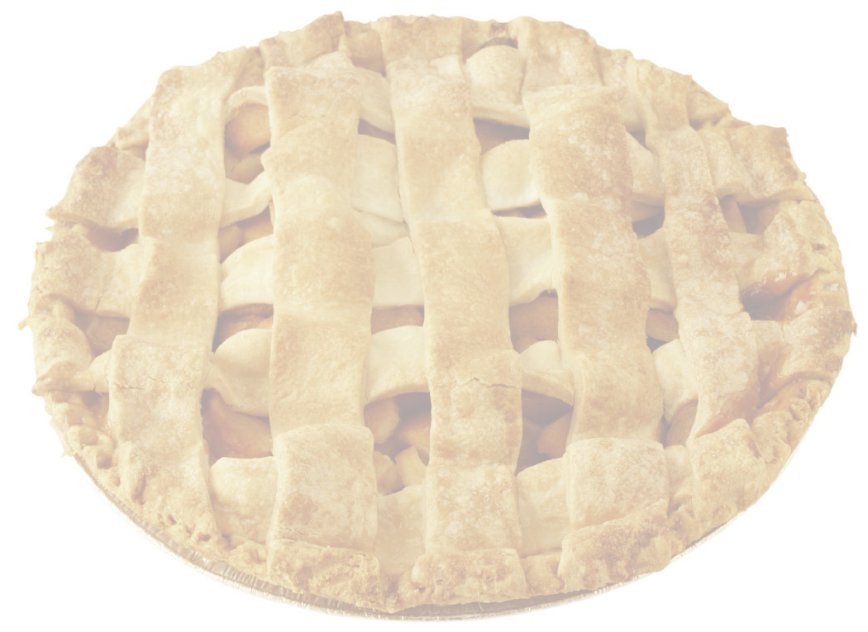
Where – Cumming Fairgrounds Covered Arena
When – July 4th, 2018 @ 5 p.m.
What – To win this competition and claim the honor of 2018 July 4th Pie Eating Champion.
Prizes – The winner will receive a trophy and a set of 4 tickets for the 2018 Cumming Country Fair and Festival.
The Rules – Must be 18 years of age to enter. Entries are limited to the first 10 contestants to register. No hands may be used. Contestants must place their hands behind their backs while eating the pie. Contestants must not touch / eat any pie until the start signal is given. The first person to finish his/her pie will throw their hands in the air to end the contest and be declared the winner. Judges will decide if pie is actually finished before ending the contest. In the event of a tie, there will be an “Eat Off” between the contestants to find the winner of the contest.
Please complete the registration form and return to Cumming Fairgrounds
Name ______________________________________________________
Date of Birth __________________________________________________________
Street ________________________________________________________________
City, State, Zip _________________________________________________________
Phone Number _________________________________________________________
All registrants must read and sign this waiver before entering
I know that eating a pie at a fast rate of speed is a potentially hazardous and an uncomfortable activity. I should not enter and eat unless I am medically capable. I realize that this is all in good fun, and I agree to be a good sport. I agree to abide by any decision of the contest officials and all of the contest rules. I assume all risks associated with eating in this type of event including, but not limited to, indigestion, that stuffed feeling, contact with other contestants, a general dislike for pie after I am done. Having read this waiver and knowing these facts, I waive and release the City of Cumming and the contest organizers from all claims of liabilities of any kind arising out of my participation in this event.
Signature _______________________________Date _____________________
Email Application to: contest@cityofcumming.net
Contact by phone: 770-781-3491

