Pizza Eating Contest Rules and Waiver
Do you love pizza? Do you think you can eat a personal pan size faster than everyone else? Then register to be a part of the 2018 Pizza Eating Contest at the Cumming Fairgrounds. You must be 18 years of age to enter and have a form of ID ready at the contest. Fill out the application and email it to contest@cityofcumming.net . Come and see if you’re the fastest.
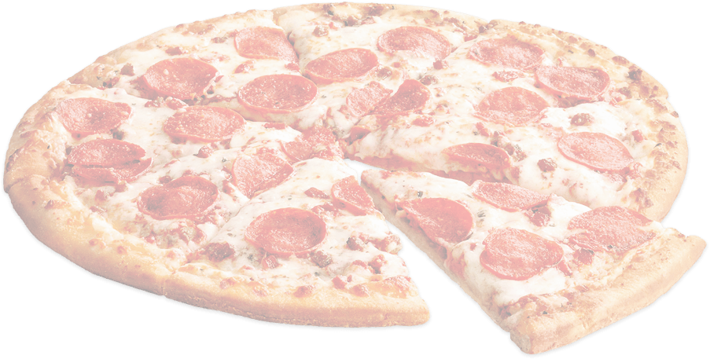
Where – Cumming Fairgrounds at the Rosati’s Booth
When – July 4th, 2018 @ 4 p.m.
What – To win this competition and claim the honor of 2018 July 4th Pizza Eating Champion.
Prizes – The winner will receive a trophy and a set of 4 tickets for the 2018 Cumming Country Fair and Festival.
The Rules – Must be 18 years of age to enter. Entries are limited to the first 10 contestants to register. Each contestant will be given 1 personal pan size pizza. Contestants must not touch / eat any pizza until the start signal is given. The first person to finish his/her pizza will throw their hands in the air to end the contest and be declared the winner. In the event of a tie, there will be an “Eat Off” between the contestants to find the winner of the contest.
Please complete the registration form and return to Cumming Fairgrounds
Name ______________________________________________________
Date of Birth __________________________________________________________
Street ________________________________________________________________
City, State, Zip _________________________________________________________
Phone Number _________________________________________________________
All registrants must read and sign this waiver before entering
I know that eating a pizza at a fast rate of speed is a potentially hazardous and an uncomfortable activity. I should not enter and eat unless I am medically capable. I realize that this is all in good fun, and I agree to be a good sport. I agree to abide by any decision of the contest officials and all of the contest rules. I assume all risks associated with eating in this type of event including, but not limited to, indigestion, that stuffed feeling, contact with other contestants, a general dislike for pizza after I am done. Having read this waiver and knowing these facts, I waive and release the City of Cumming and the contest organizers from all claims of liabilities of any kind arising out of my participation in this event.
Signature _______________________________Date _____________________
Email Application to: contest@cityofcumming.net
Contact by phone: 770-781-3491

