Sponsored and Directed by the Miss Georgia Girl /Lake Lanier Pageants
TITLES AGE DIVISIONS & ATTIRE TIME OF COMPETITION

Baby Miss Cumming Fair 0-35 months Pageant, Party or Sunday Dress 10:00 a.m. – NO MAKEUP Tiny Miss Cumming Fair 3-4 Pageant, Party or Sunday Dress 10:30 a.m. – NO MAKEUP
Petite Miss Cumming Fair 5-6 Pageant, Party or Sunday Dress 10:45 a.m. – NO MAKEUP Little Miss Cumming Fair 7-9 Pageant, Party or Sunday Dress 11:15 a.m. – NO MAKEUP Jr. Teen Miss Cumming Fair 10-12 Long Gown 11:30 a.m.
Teen Miss Cumming Fair 13-16 Long Gown 11:45 a.m.

*Miss Cumming Fair 17-24 Long Gown 12:00 noon
Please come dressed ready to compete. Dressing areas are very limited.

*Will compete in the Miss Georgia Fairs pageant and may be asked to make appearances during the year.
Pageant to be held at the 2018 Annual Georgia Association of Agricultural Fairs convention in January 2019

*Call for more information 770.833.3842
One winner per age division and two alternates. All contestants will receive an award.
One Supreme Queen (contestant with the highest score in the entire pageant) will take home $150 cash, banner, large crown and a large trophy!
One Most Beautiful Queen (contestant with the highest beauty score in entire pageant) will take home $75 cash, banner, large crown and a large trophy!

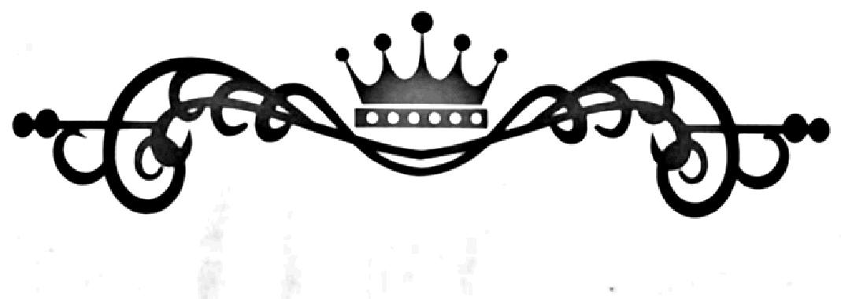
Enter beginning at 9:30 a.m. through Gate C. Gate admission to the Cumming Country Fair for the contestant is included in pageant entry fee. Your hand will be stamped for re-entry until 3 p.m. for SAME DAY, OCT. 6th ONLY.

Miss Cumming Fair

** Age Division as of October 6, 2018 ** One winner per age division receives a crown, banner and award.
Two alternates in each age division will receive an award.
All contestants will receive a participation award.

Mail entry form below with the entry fee/photogenic entry fees to:
Pennie Stathes, 8920 Lansbury Ct., Cumming, GA 30028- OR - Enter online at www.misscummingfair.com Make check payable to: Pennie Stathes -- For additional information call: Pennie Stathes: 770-833-3842

*******************************************************************************************************

__________Entry Fee: $65.00 THROUGH 9/22/18– BEGINNING 9/23/2018 ENTRY IS $75

___________Optional: Miss Photogenic for Each Division: $5.00 –You Must BRING Own Photo (B&W or Color) 8 X 10 or less ___________Optional: Supreme Queen Entry - $10. –one winner in pageant ___________Optional: Most Beautiful Queen Entry - $10. – one winner in pageant

Office use
Age Division: _______________________________________________ Photogenic____________ Number: _________________

E-Mail Address: ____________________________________________________________________________________
Name: ________________________________________________ Age: ____________ Date of Birth: _______________________ Parent’s Name: _____________________________________________________ Phone #: _______________________________

Address: _______________________________________________ City: ________________________ Zip: __________________
School: _________________________________________ Grade: _______ Sponsor: ____________________________________ Activities/Hobbies: Please list exactly as you wish the emcee to read:

________________________________________________________________________________________________

______________________________________________________________________________________________________________________
* By submitting this signed application, I understand that all judges’ decisions are final and will not be disputed. I understand that no makeup or winglets are allowed on any contestant ages 0-9 years old. Any negative behavior from contestant, parent or visitor of, will result in contestant disqualification with all awards being forfeited. There are no refunds for any reason. No type of slander, bad sportsmanship, or bashing, will be tolerated from contestant, parent or visitor of. All slanderous, damaging, false, detrimental actions, spoken, written, or physical by any contestant, parent or visitor of, regarding this pageant or individual associated with or a part of, can be prosecuted to the fullest extent of the law. Miss Georgia Girl, Miss Forsyth County, Miss Lake Lanier, Pennie Stathes, John Stathes, or any volunteers will not be held liable for any injury to any individuals before, during, or after any event. Any photos taken that contain contestants, parents or visitors of, are the property of Miss Georgia Girl and can be used in promotional advertising. I further understand that without this signed statement, my daughter or I cannot compete in this event. Returned checks for any reason will have a $40 fee plus collection charges. ANY AND ALL SOLICITATION BY ANY OTHER PAGEANT SYSTEM IS PROHIBITED UNLESS PREVIOUSLY APPROVED BY DIRECTORS. COPYING OF ANY MATERIAL USED AT THIS PAGEANT - WRITTEN, ENTRY FORM, WEBSITE, BY PHOTOGRAPH, OR VERBAL IS STRICKTLY PROHIBITED.
Signature of Contestant or Parent/Guardian:
__________________________________________________________________________________Date_______________________________

